**Exercise 1: Control Structures**

**Scenario 1:** The bank wants to apply a discount to loan interest rates for customers above 60 years old.

**Question:** Write a PL/SQL block that loops through all customers, checks their age, and if they are above 60, apply a 1% discount to their current loan interest rates.

DECLARE

CURSOR customer_cursor IS

SELECT c.CustomerID, l.LoanID, l.InterestRate

FROM Customers c

JOIN Loans l ON c.CustomerID = l.CustomerID

WHERE EXTRACT(YEAR FROM SYSDATE) - EXTRACT(YEAR FROM c.DOB) > 60;

BEGIN

FOR loan_record IN customer_cursor LOOP

UPDATE Loans

SET InterestRate = InterestRate*0.99

WHERE LoanID = loan_record.LoanID;

DBMS_OUTPUT.PUT_LINE('Applied 1% discount to loan ID: ' || loan_record.LoanID);

END LOOP;

END;

**Scenario 2:** A customer can be promoted to VIP status based on their balance.

**Question:** Write a PL/SQL block that iterates through all customers and sets a flag IsVIP to TRUE for those with a balance over $10,000.

ALTER TABLE Customers

ADD isvip VARCHAR(5);

DECLARE

CURSOR customer_cursor IS

SELECT CustomerID, Balance

FROM Customers

WHERE Balance > 10000;

BEGIN

FOR customer_record IN customer_cursor LOOP

UPDATE Customers

SET IsVIP = 'TRUE'

WHERE CustomerID = customer_record.CustomerID;

DBMS_OUTPUT.PUT_LINE('Set VIP status for customer ID: ' || customer_record.CustomerID);

END LOOP;

END;

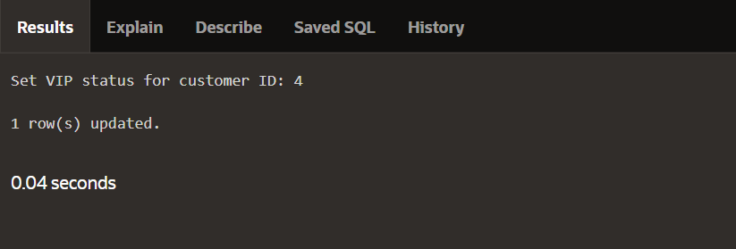

**Scenario 3:** The bank wants to send reminders to customers whose loans are due within the next 30 days.

**Question:** Write a PL/SQL block that fetches all loans due in the next 30 days and prints a reminder message for each customer.

DECLARE

CURSOR cursor_loan IS

SELECT c.customerid, c.name, l.loanid, l.loanamount, l.enddate

FROM customers c

JOIN loans l ON c.customerid = l.customerid

WHERE l.enddate BETWEEN SYSDATE AND SYSDATE + 30;

BEGIN

FOR rec IN cursor_loan LOOP

DBMS_OUTPUT.PUT_LINE('CUSTOMER ID : ' || rec.customerid);

DBMS_OUTPUT.PUT_LINE('CUSTOMER NAME : ' || rec.name);

DBMS_OUTPUT.PUT_LINE('LOAN ID : ' || rec.loanid);

DBMS_OUTPUT.PUT_LINE('DUE ON : ' || TO_CHAR(rec.enddate, 'DD-MM-YYYY'));

END LOOP;

END;

